**Europe hits important milestone in the manufacturing of ITER Vacuum Vessel**

[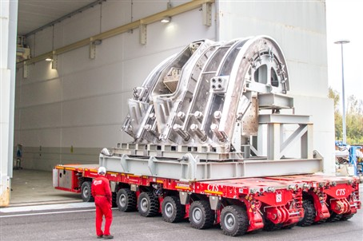](https://f4e.europa.eu/Downloads/News/IMG_9430_26112019-261120191200-Large.jpg)

Lower segment of sector 5 of the ITER Vacuum Vessel loaded on a trailer to go through radio graphic tests. Works performed in Mangiariotti, located in Monfalcone, Italy. Europe is responsible for five out of the nine sectors of the component. F4E has signed a contract with the AMW consortium consisting of Ansaldo Nucleare, Mangiarotti, Walter Tosto.

There is an upbeat feeling in Mangiarotti, Monfalcone, (Italy), as the trailer carrying the most complex segment of sector 5 is slowly driving through the doors of its workshop. The shiny surface of the 125 t stainless steel component is graciously making an entrance to undergo further checks till it goes in a bunker for radiographic tests. The engineers standing next to it look tiny. It feels as if the Trojan horse on wheels has arrived. And yet its purpose is fundamentally different. The pieces of the vacuum vessel, once welded, will form the chamber that will house the fire – the plasma of the biggest fusion device.

Probably this is the most demanding piece that Europe has completed so far for the ITER Vacuum Vessel, and for those involved it has been a learning process for the fabrication of the segments to follow. Europe is responsible for five of the nine sectors of the entire component. F4E has entrusted their manufacturing to the AMW consortium made of Ansaldo Nucleare, Mangiarotti, Walter Tosto and an extensive chain of sub-suppliers. Today, after nearly two years, the some of the most challenging manufacturing tasks have been completed. And some ahead of time. For example, the installation of the poloidal ribs, connecting from top to bottom the inner-shell with the outer-shell of the vacuum vessel. The next step will be the installation of the toroidal ribs reinforcing the internal structure of the component from left to right.

Fabio Ceccanti, F4E's Project Manager following the fabrication of sectors 5 and 4, explains that "significant progress has been achieved during the last months, and in the case of the poloidal ribs they were completed earlier than initially foreseen. The good collaboration between suppliers, F4E , ITER Organization and the other ITER Parties played an important role." This is the result of rigorous project management, careful planning, multiple supplier interfaces and more than 80 people on the ground mainly from Mangiarotti, Walter Tosto, and ProBeam. Each vacuum vessel sector consists of four segments. They are all produced piece by piece and subsequently they will have to be welded in a seamless manner to become one sector. Later, all sectors manufactured in Europe and Korea will be welded to form the hermetically sealed chamber.

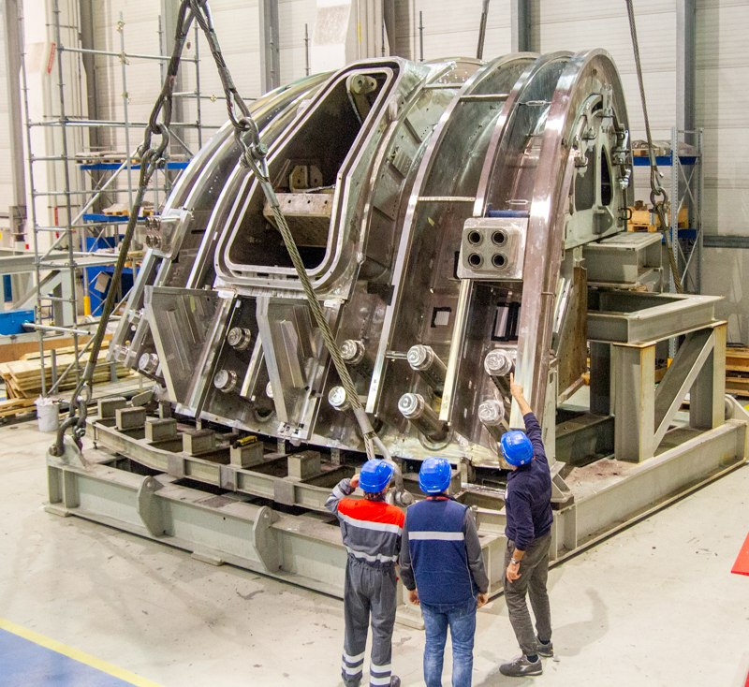

Lower segment of sector 5 of the ITER Vacuum Vessel before installation of In Wall Shielding Blocks. Works performed in Mangiarotti, located in Monfalcone, Italy. Europe is responsible for five out of the nine sectors of the component. F4E has signed a contract with the AMW consortium consisting of Ansaldo Nucleare, Mangiarotti, Walter Tosto.

The lower poloidal segment– known in the ITER jargon as PS4— is made of more than 300 pieces. It stands out because of its dimensions, its complex geometry and the amount of welding. "The next step will be the installation of the in-wall shielding blocks which in essence will contain the neutrons resulting from the fusion reaction, and last but not least, the welding of the outer-shell of the component," explains Andres Dans Alvarez De Sotomayor, F4E's Technical Officer following the fabrication at Mangiarotti. "The manufacturing approach that we opted for in the production of the sectors is reverse engineering. Basically, any distortions resulting from fabrication are taken into account and compensated in the fabrication of the other parts. It is a time-consuming exercise, but necessary, so that the end result is in compliance with the tight tolerances requested. For the size of such component and of such geometry this is no easy task," he adds.

For Cristian Casanova, F4E's Vacuum Vessel Programme Manager, "the timely delivery of the ITER Vacuum Vessel sectors is the backbone of the revised manufacturing approach put in place by F4E, AMW and ITER Organization. The significant progress of the most complex segment demonstrates how as one team we pulled together our resources, mitigated risks and delivered in line with the technical requirements."